CLEAN UP DAY!

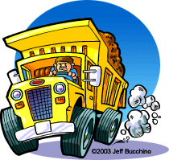

**ALPINE BREWSTER COUNTY**

**Saturday, May 3rd , 2025, 9 a.m. to 3 p.m.**

Where?

What Is It? How?

Cost?

Alpine Landfill, 8 miles East on Hwy 90

A chance to easily dispose of large junk and rubbish,

Brewster County Trucks will accept your junk & rubbish. A separate tire trailer will also be on hand to receive old tires. County Trucks will haul your junk off to the Landfill

FREE to all Alpine Residents

What items ARE Plain old junk, like furniture and

acceptable? household items, mattresses & bedding, appliances (**please note appliances using refrigerant must be certified that the refrigerant has been removed and disposed of properly**), water heaters, carpet, & tires.

* Please keep tires separate from other junk.
* We have to be able to get the items in a Dump Truck, one way or another!

What **CANNOT** be Dump trailers with debris with dirt, car

received? batteries, petroleum products, pesticides, free liquids, hazardous waste, asbestos, paint, etc.